**Lab 1: Matlab Refresher & Data Handling** 11-14-2016

Report Author: Jesus Carriedo

Lab Team: Jesus Carriedo

Allen Hermosillo

Lab Date: 11-7-2016

**Summary**

The lab consisted of learning how to use matlab by conducting five excercises. In order to learn the program, the experiment involved exercise reshape a matrix, find min and max, find the number of elements in an array, open excel files and be able to use data from the excel file. The final exercise helped the team learn how to label a graph in mat lab, and be able to set up a curve the best fits the data. The lab was done by using Matlab. In addition, when help was needed the exercise the expertise of our lab instructor will help us solve the problems we had.

**Exercises**

**PART 1**

Record the value of the motor resistance: R= 5.6 ohms

Voltage measurement

Table 1: Voltage Measurements

|  |  |
| --- | --- |
| Inputs | Voltages Measured |
| 0 | 0.02 |
| 2 | 1.67 |
| 4.8 | 3.94 |

Table 1 illustrates the voltages that were measured across the jumper pin and ground. This is located behind the motor connection port. The inputs that were changed are from the constant box on the Simulink model.

Current Measurements

The recorded value for the current is 45 milla amps.

Speed versus Torque Graph:

Table 2: Speed and Torque graphs

|  |  |  |  |
| --- | --- | --- | --- |
| Steady state speeds (V) | Angular Velocity | Measured Voltage (V) | Measured Current (ma) |
| 2.5 | -13.8 | 2.07 | 29.6 |
| 3.5 | -19.5 | 2.89 | 35.5 |
| 4.5 | -25.1 | 3.71 | 38.1 |

Do the measured voltages match the voltage set in the Simulink diagram when you use the multi-meter to measure the voltage?

Table 3: Comparison of Measured Voltages

|  |  |  |
| --- | --- | --- |
| Values inputted to Simulink Diagram | Measure Voltages | Percent Error |
| 2.5 V | 2.07 V | 9.556 % |
| 3.5 V | 2.89 V | 13.556% |
| 4.5 V | 3.71 V | 17.556% |

Table 3 shows the percent error when comparing the measured voltages with the voltages that were inputted in Simulink. The percent error comparison demonstrates that the values do not match; consequently, the measured values are not within 5% of the values on the Simulink

model. The percent error increase has the voltages increase. The percent error because almost 20 % when 4.5V where inputted to the Simulink model. Base of the data on table 3, my partner and I did not generated good measured values.

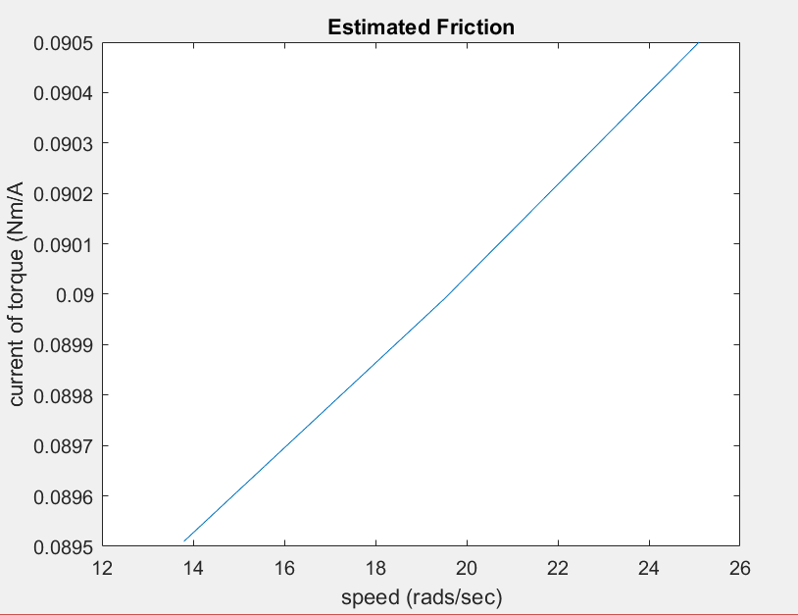

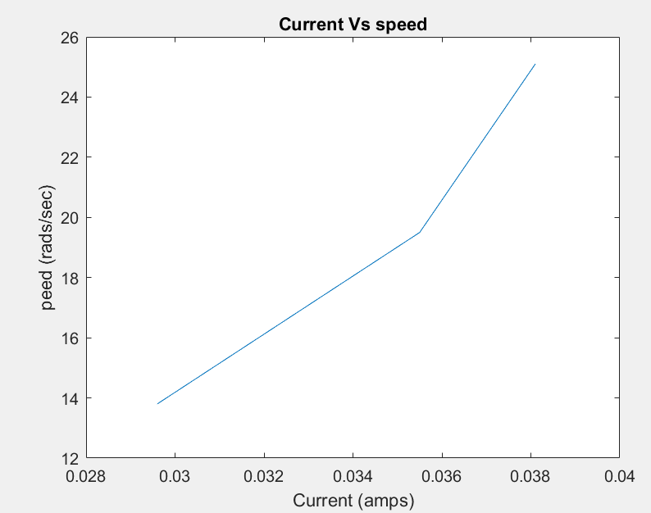

What are your experimental values for

**PART 2**

Table 3: Percent Error of K values

|  |  |
| --- | --- |
| K (Vs) | Percent Error |
| 6.667 | 14.30% |
| 6.747 | 15.70% |
| 6.766 | 15.98% |

|  |  |
| --- | --- |
| **Back emf Constant (volt/(rad/sec)** | |
| Kb1 | 0.137988 |
| Kb2 | 0.137988 |
| Kb3 | 0.139308 |

|  |  |
| --- | --- |
| **Torque Constant (Nm/A)** | |
| Kt1 | 0.08964 |
| Kt2 | 0.0897 |
| Kt3 | 0.0905 |

|  |  |
| --- | --- |
| **Viscous Damping Constant** | |
| b1 | 0.000192 |
| b2 | 0.000163 |
| b3 | 0.000137 |

|  |  |
| --- | --- |
| **Steady State Gain** | |
| k1 | 6.666667 |
| k2 | 6.747405 |
| k3 | 6.765499 |

|  |  |
| --- | --- |
| **Inertia** | |
| J1 | 0.008824 |
| J2 | 0.008724 |
| J3 | 0.008778 |

Calculated 𝜏exp = 3.675

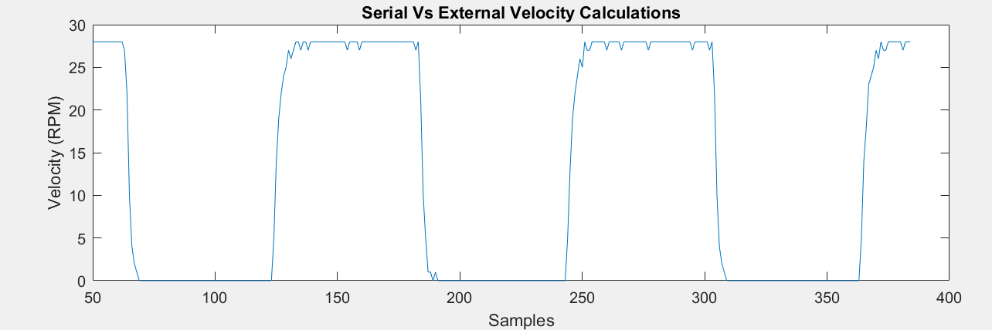

Figure 2: Serial Vs External Velocity.

Kt can be determined by applying known loads and measuring the current. For this motor, it is determined that Kt is approximately 65% of Kb. Why?

Kt is assumed to 65% of kb because the NXT moto contains a gear train. A other factor that places into kt being a approximately 65% of kb is because of the losses due to the gears.

If all the linear motor parameters are determined from separate experiments, the computed time constant for the resulting linear model is approximately 𝜏=.042. How does your value for the time constant compare to this - why?

The value my partner and I achieve in are 𝜏exp = 3.675 comparing to 𝜏=.042 will be a large margin of error 𝜏=.042 which will show the data to be inaccurate. This value is very small because in the example in the lab manual 𝜏 is between 6 and 18.